
Human Biology – General Year 11 Task 7 – Unit 1

Assessment type: Test
Conditions:
Period allowed for completion of the task:
- One revision lesson in class
- One lesson conducting test in class
Task weighting: 7% of the school mark for Units 1 and 2 _________________________________________________________________________________ Task 5: Test- Digestive and Urinary System (46 marks)
Multiple Choice Questions:
- What is the function of the kidneys?
a. Remove carbon dioxide from the blood
b. Filters the blood of toxins and nitrogenous wastes
c. Maintains water and pH balance in the blood
d. Both b and c

- Which of the following is an example of an agent in chemical digestion?
- Stomach acid
- Hernia
- Urine
- Nitrogenous waste

- What is peristalsis?
a. The contraction and relaxation of non-adjacent segments of circular smooth muscle in the intestines
b. The principle mechanism of movement in the esophagus, although it also occurs in the stomach
c. The absorption of water from the large intestine
d. Food being broken down into smaller fragments through mastication

- Digestion begins in the…
a. Pharynx
b. Pancreas
c. Lungs
d. Mouth

- The liver produces a fluid known as ….
a. Sodium bicarbonate
b. Hydrochloric Acid
c. Digestive fluid
d. Bile

- The urinary system is a part of the…
a. Excretory system
b. Digestive system
c. Respiratory system
d. Circulatory system

- The tube that carries urine from the bladder is called the…
a. Ureter
b. Urethra
c. Nephron
d. Kidney

- The kidneys, ureters, urethra and bladder make up the:
a. Excretory System
b. Urinary System
c. Digestive System
d. Respiratory System

- Urea and uric acid are excreted by terrestrial animals. Instead, aquatic animals excrete:
a. Carbon Dioxide
b. Water
c. Oxygen
d. Ammonia

- Two important processes that occur in the kidney are:
a. Filtration and reabsorption
b. Absorption and reabsorption
c. Urination and defaecation
d. Urination and filtration

Short Answer Questions:

- Define the following terms: (3 marks)
  - Filtration: _____________________________________________________________________________________________________________________________________________________________________________________________
  - Segmentation:
_____________________________________________________________________________________________________________________________________________________________________________________________
  - Enzyme:
_____________________________________________________________________________________________________________________________________________________________________________________________
- What is the difference between chemical and mechanical digestion? (3 marks)
______________________________________________________________________________________________________________________________________________________________________________________________________________________________________________________________________________________________________________________________________________________________________________________________________________________________

- What are the three important functions of the pancreas? (3 marks)
______________________________________________________________________________________________________________________________________________________________________________________________________________________________________________________________________________________________________________________________________________________________________________________________________________________________

- Complete the table (4 marks)
Enzyme | Role
Proteases
Amylase
Nuclease
Lipase

- Ammonia, urea and uric acid are nitrogenous wastes. List them in order from least toxic to most toxic. (3 marks)

- ________________________________________
- ________________________________________
- ________________________________________

- Label the following diagrams (12 marks)

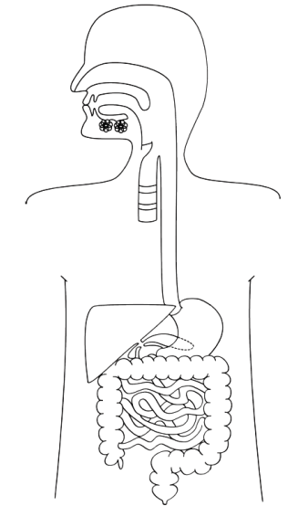

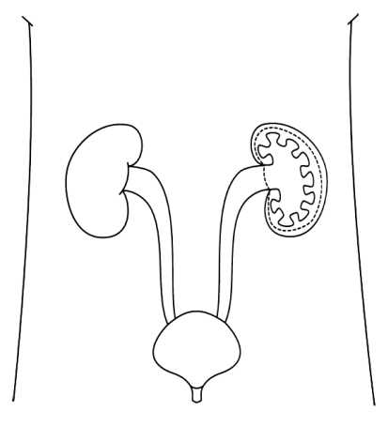

Extended Answer Question:

- Identify and describe one example of a digestive disorder in the human body. In your answer be sure to: (8 marks)
- Identify the disorder
- Identify the symptoms
- Identify the cause if known
- Identify the treatments

______________________________________________________________________________________________________________________________________________________________________________________________________________________________________________________________________________________________________________________________________________________________________________________________________________________________
______________________________________________________________________________________________________________________________________________________________________________________________________________________________________________________________________________________________________________________________________________________________________________________________________________________________
______________________________________________________________________________________________________________________________________________________________________________________________________________________________________________________________________________________________________________________________________________________________________________________________________________________________
______________________________________________________________________________________________________________________________________________________________________________________________________________________________________________________________________________________________________________________________________________________________________________________________________________________________

